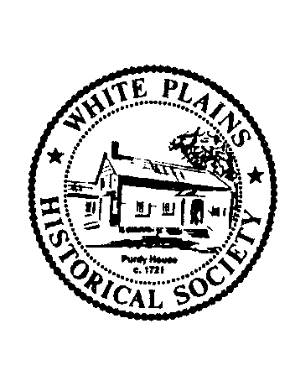

White Plains Historical Society

26th Annual Dinner Program

Thursday, May 7, 2015

Welcome

**Robert Hoch, President**

Historic Honor Guard

**Led by Denis Jones, Trustee**

Pledge of Allegiance

**Ted Lee, Jr., Trustee**

National Anthem

**Accompaniment by Suzanne Hoch**

Installation of Trustees & Officers

**John Vorperian, 1st Vice President**

Grace

**Father Ralph Berg, C.M.F. – Pastor, Our Lady of Mt. Carmel Church**

(Dinner is served)

Citizen Extraordinaire Award to

Bob Hyland

**Presented by Chuck Mercein**

Key Note Address

*Mint Juleps with Teddy Roosevelt: The Complete History of Presidential Drinking*

**Mark Will-Weber**

Historic Preservation Raffle

Dinner by Caperberry Events & Catering

Flowers Provided by Amodio’s Garden Center, Nursery and Flower Shop